St. Mary Catholic School
Business & Strategic Plan

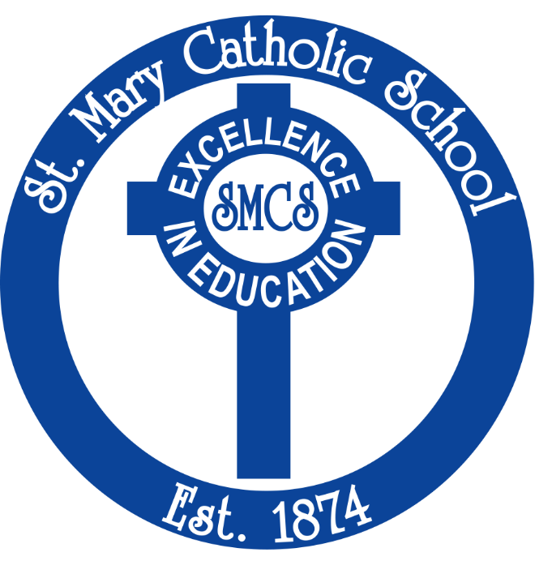

Dr. Amy Summers & Father James Boric
Fall 2023

Executive Summary
Who we are: St. Mary Catholic Elementary School is a historic pre-K through 8 school located in the heart of downtown Hagerstown since 1874. We nurture the body, mind and soul of every student.
Mission: Saint Mary Catholic school, in collaboration with our parish and parents, makes it our mission to educate children in Truth. We draw upon both our Catholic Tradition of the liberal arts and the current Archdiocesan curriculum to guide students in their pursuit of Truth, Beauty, and Goodness. Recognizing that each student is a beloved child of God, we respect the freedom of every student and instill in them a spirit of Love. We exist to form intelligent and balanced citizens of heaven and earth.
Vision of Catholic Education:

- Involves the integral formation of the whole person, body, mind and spirit, in light of his or her ultimate end and the good of society.
- Seeks to know and understand objective realty, including Transcendent Truth, which is knowable by reason and faith and finds its origin, unity and end in God.
- Promotes human virtues and the dignity of the human person, as created in the image and likeness of God and modeled on the person of Jesus Christ.
- Encourages a synthesis of faith, life and culture.
- Develops a Catholic worldview and enables a deeper incorporation of the student into the heart of the Catholic Church.

Student Acquisition
St. Mary Catholic School has approximately 187 students with a capacity of about 400 students at our current campus. Students come from the Tri-State area (WV, PA and MD), with the majority coming from Washington County. With a new marketing plan, we expect to be able to attract more students from the Frederick area as well as the homeschool network in Washington County.
Future of St. Mary Catholic School
With a new Principal and a Pastor who share a strong common vision for Catholic education, the future of our school is bright. With Dr. Summer’s connections in the Hagerstown area, families who knew her for St. Maria Goretti Catholic High School will likely follow her to St. Mary Catholic School as well as recommend her to younger families. She is also well established in West Virginia. In addition, Father James Boric has a growing congregation at St. Mary’s parish. His voice goes a long way in attracting new parents to St. Mary Catholic school. In addition, St. Mary’s parish has a growing youth group—who come from an hour away to learn the faith on our campus. Word is spreading about the good things that are happening here.

Market Research (National)
Larger Market (in which Catholic School Operate)
Catholic schools are dealing with a number of external factors which impact enrollment:
- Population growth has slowed from 13.15% in 2000 to 7.35% in 2020
- The Pew Research Center study found that 65% of American adults described themselves as Christian, down 12 percentage points from a similar study in 2009.
- There is a decline in religious practice.
- Catholic enrollment has declined from 2.7 million to 2.1 million over the past 20 years, while there has been a growth from 1.2 million to 1.4 million in non-sectarian private schools.
- There is tremendous growth in Maryland and in the United States among schools with a strong Catholic identity and a classical education. We are seeing Chesterton Academies spreading in our state. Parents are attracted to authentic Catholic education, and are willing to travel to send their children to such schools.

Catholic School Benefits
As stated in the Cardinal Newmann guide for Catholic Schools, a Catholic education:
- Involves the integral formation of the whole person, body, mind and spirit, in light of his or her ultimate end and the good of society.
- Focuses on objective realty, including Transcendent Truth, which is knowable by reason and faith and finds its origin, unity and end in God.
- Promotes human virtues and the dignity of the human person, as created in the image and likeness of God and modeled on the person of Jesus Christ.
- Encourages a synthesis of faith, life and culture.
- Develops a Catholic worldview and enables a deeper incorporation of the student into the heart of the Catholic Church.
In short, Catholic schools are the only schools which truly build up the entire person—body, mind and sou—and root them in all that is true, good and beautiful. This is a tremendous benefit to parents who seek traditional values for their children.

Catholic and Private School Costs in and around Washington County

The cost per student at St. Mary Catholic School is approximately $10,500 a year. Our average tuition yield is approximately $5,500 a year.

The tuition of our most direct competitors are as follows:
- Grace Academy: Yearly Tuition varies between $8,625 (for grades pre-K – 5) and $9,038 (from grades 6-8).
- St. James School: Yearly Tuition varies between $36,000 (for day students) to $58,000 for boarding students. We do lose students to St. James in 8th grade.
- St. John Regional Catholic School, Frederick, MD: Yearly Tuition varies from $8,480 to $9,910 for grades K-8.

Market Research (Local)
Archdiocese of Baltimore (AOB)
The AOB encompasses eight counties and the city of Baltimore. There are 59 Catholic Schools serving almost 24,000 students. St. Mary Catholic School has 187 students. We are the only Catholic elementary school in Washington County.
St. Mary Catholic School Feasibility
St. Mary Catholic School is losing about $350,000 a year as we have about 60 students less than we would need to break even from an operational standpoint. However, Dr. Summers and Fr. Boric are working on a plan to raise awareness and donations to keep the school open for many decades to come.
Demographics
Population | 2020 | 2010 | % increase | Median Household Income
Washington | 154,705 | 147,430 | 4.9% | $59,140
Franklin | 155,932 | 149,618 | 4.2% | $62,484
Berkeley | 122,076 | 104,169 | 17.2% | $62,370
Frederick | 271,717 | 233,385 | 16.4% | $103,516

St. Mary Catholic School at a Glance
2023-2024
Current Enrollment: 187
Administration: 2
Staff: 13
Faculty: 17
School Board: 7
Average Class Size: 19
Tuition: $7,950
Average Yield: $5,334
Percentage of Catholic Students: 75%
Yearly Expenses: $2,000,000
Financial Aid: $166,750
Marketing
Saint Mary Catholic School targets Catholic and non-Catholic families by:
- Advertising at the three local parishes in Hagerstown, MD which include St. Mary’s, St. Ann’s and St. Joseph’s.
  - Bulletin Announcements
  - Pulpit announcements
  - Town meetings in which the Principal and Pastor of St. Mary’s provide a power-point presentation on the value of Catholic School education
- Promotional Letters written by Father Boric who is a trained, professional copy-writer in direct mail and web promotions
  - These are our most effective means to get the vision and mission to people around the Hagerstown and Baltimore area. Father has developed a core group of investors in the Baltimore area who will support Catholic school in Hagerstown, MD.
  - These letters get forwarded to people all over the Archdiocese and generate both admissions interest and donations.
  - These letters are sent to home school families who may re-consider sending their children or our school.
- Annual Fund Direct Mail organized by Our Sunday Visitor
  - Mails a State of the School report, Annual Fund Ask, 1st follow-up Ask, 2nd follow-up Ask, and thank you letters to 700 recipients.
- Inserts and Articles in local Hagerstown magazines
- Social Media
  - A strong presence on FaceBook
- Personal contact with local Pre-K schools

Strategic Plan & Timeline
Phase 1: Increase Catholic Identity and Academic Rigor (2024-25) by offering:
- Daily Mass for our students

- High school classes for our middle school children (so they can earn high school credits even before they graduate middle school!)

- The finest, virtue-based curriculum in the country (created by the Nashville Dominican Sisters) for all students in kindergarten through grade 8. It is called “Virtues in Practice.” You can read all about it here.

- Regular access to confession and Eucharistic adoration as well as everything which is true, good and beautiful

- Rigorous math and science courses for all our students

- A sacramental program that most high schools don’t offer—so that our graduates KNOW the Catholic Faith through and through.
Phase 2: Increase Enrollment by Adding a Second Pre-K Class (2024-25)
A key element to long term sustainability for SMCS is to increase enrollment. Our goal is to reach 245 students by 2028. We will facilitate this increase through a three-phase approach:
- In the 2024-25 school year, we will add a second pre-k classroom to allow for up to 20 additional students. Based on demand for the 2023-24 school year, we believe that we can enroll enough students in a second pre-k track to make it financially viable. Depending on the number of students, we will have the option to increase the number of classes in kindergarten, first, second grade, etc. in subsequent years as appropriate.
- We will target incentive-based messaging campaigns and experiences for our historically “transitional” years, such as 5th grade (preparing to enter “Middle School”) and 7th grade (preparing for 8th grade and high school). When we’ve had attrition in the past, it has centered around those age groups.
- We intend to add classes for high school credit for our 8th graders, which should incentivize them to stay at SMCS instead of leaving after 7th grade for an early “jump start” at a new high school.

Phase 3: Potentially Add a High School to our Grade School (2025-2027)
With the closing of St. Maria Goretti Catholic High School, there is a need and a desire for a secondary school in Hagerstown. Dr. Summers has the ability to systematically add a high school tract a year at a time—if there is demand. To do this, we would have to invest about $500,000 in our current facilities based on a recent facilities study led by the Archdiocese of Baltimore.

As given by the Cardinal Newman Society in the Introduction of its document “Catholic Curriculum Standards.”
Tuition & Assistance - Grace Academy MD (gaknights.org)
Tuition & Financial Aid - Saint James School | Boarding School in Maryland, Private School MD (stjames.edu)
Catholic School Tuition Rates In Frederick, MD | St. John Regional Catholic School (sjrcs.org)

